

Lesson Plan – Carers Week: Young Carers Awareness
Duration : | 40 - 50 minutes
Resources required: | - Flip chart paper  - Cut outs of 4 large people (or groups can make their own if time)  - Marker pens (plus optional art materials)  - Handouts/documents:  - Teachers notes about Carers Week  - Create a Virtual Carer – group instructions  - Create a Virtual Carer – scenario for four groups  - Young Carers Assessments
Aims of the lesson | - Raise awareness about young carers, encouraging openness and support, and promoting the benefits of young carers identifying themselves to a trusted staff member  - Ensure young carers and others know about the laws giving young carers more rights (the right to an assessment)
Objectives | - Understand who young carers are - definition, characteristics  - Understand why young carers might have different needs and why / how these might impact on their life and education  - Reduce the stigma around being a young carer  - Ensure that young carers are aware of their right to a Young Carers Assessment  - Celebrate Carers Week
Starter activity  10 minutes  (20 minutes with film) | - Introduce Carers Week – See: Handout - Teachers notes  - Introduce who are young carers and what they do (give a brief overview of some of the practical and emotional support that a young carer may be providing and how this may impact upon the young person educationally, physically, socially & emotionally)  Option to show a film made by young carers (approx 10 mins each):  - ‘We Care, Do You?’ (for primary schools) or  - ‘Our Stories’ (for secondary schools)  Available at https://www.sheffieldyoungcarers.org.uk/watch-our-films  PLEASE CHECK NONE OF YOUR PUPILS OR SIBLINGS APPEAR ON THE FILM FIRST – check how they feel about it being shown if there is anyone from your school on the film
Core Activity  20 minutes | Design a Virtual Young Carer  - Divide into four groups.  - Give each group a large card figure, pens and/or post it notes/art materials, one of the young carer scenarios, and the instructions explaining the task.  - Handout – Create a Virtual Carer – group instructions  - Handout - Create a Virtual Carer – scenario for four groups  - With help from the teacher, groups should spend 10 minutes (or longer if you have time) creating their character and writing / drawing on the figure to show:  - What their young carer might do on a typical day (including practical/personal/emotional/emergency care)  - How they might feel about this  - How this impacts on their education / health / social life  - When the task is ended, each group should briefly present their young carer to the group. Key messages to draw out:  - Anyone can be a young carer  - Caring, especially emotional care, is often hidden / not seen by other people Young carers have extra challenges to face every day as well as attending school  - Young carers have new rights to get help. Give out Handout – Young Carers Assessments
Plenary Activity  10 Minutes | - Ask the group if is there anything that they think would help the young carer.  - Explain that support is available to young carers through:  - School  - ‘Know Your Rights’ booklet (online) http://www.youngcarer.com/resources/ycif/know-your-rights  - Sheffield Young Carers Project  - Everyone in school helping each other  - Thank-you and close

Teachers’ notes about Carers Week:
Supporting information for staff delivering assemblies and lessons

About Carers Week
Carers Week is an annual campaign to raise awareness of caring, highlight the challenges carers face and recognise the contribution they make to families and communities throughout the UK.
This year we're focusing on building Carer Friendly Communities that support carers to look after their loved ones well, while recognising that they are individuals with needs of their own.

Get involved
Carers Week is brought to life by the individuals, groups and organisations holding events and taking action throughout the UK.
Whether you’re thinking big or looking for a simple action to make a difference, our Get Involved Guide is brimming with ideas, inspiration and resources to help you.
When you've decided what your Carers Week events or activities will be, make sure you add them to our events directory so you can receive your Carers Week resource pack and draw attention to your activity. Our guide to Being Carers Week will help you look the part and make the most of the Carers Week brand.
For further information see: http://www.carersweek.org/

Create a Virtual Young Carer:
Group Instructions

In your group, using words and/or pictures,
create a virtual young carer.

Here’s what you need to include:

- Name

- Age

- What help does the young person provide to their family member? (think about tasks they do but also the emotional help they give)
- How do you think your young carer feels about the help he/she provides?
- How might this affect their school life, their health and their social life and friendships?

Feedback to the class

Create a Virtual Young Carer: Scenarios
Group 1  I care for: My mum  Why? My mum has mental health issues  Background:  I have two younger sisters at home and my mum is a single parent.  My mum finds it hard to leave the house and often cries. | Group 2  I care for: My brother  Why? My brother has autism and ADHD  Background:  My brother is 14 years old – he is my only sibling.  He can get angry and shout and lash out.  Mum and dad both work.
Group 3  I care for: My dad  Why? My dad drinks too much alcohol  Background:  My dad had an accident and can no longer work so my mum has to work long hours at night.  When dad drinks, he gets sad and falls asleep. | Group 4  I care for: My granddad  Why? My grandad has throat cancer  Background:  Granddad lives close by on his own.  Granddad gets frustrated when people don’t understand him.

Young Carers Rights:
Young Carers Assessments
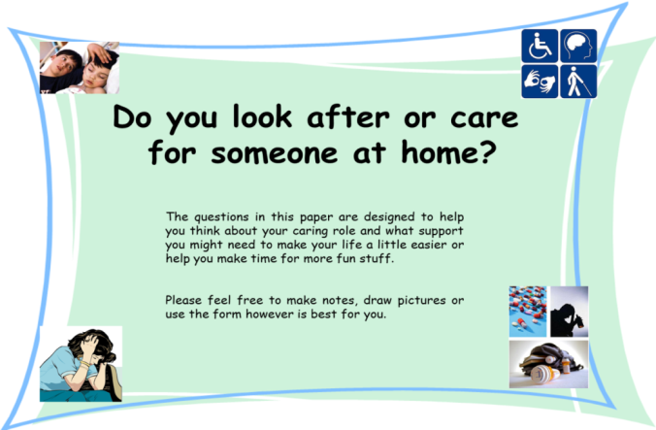
- In 2015, young carers got the right to an assessment, which means they have been recognised properly in the law for the first time!
- An assessment is a booklet to help you tell an adult about your caring at home. This will help you and the adult find ways to make your life and your caring role easier.
- To find out more, speak to a staff member you trust or go to : https://www.sheffield.gov.uk/caresupport/carers/youngcarers.html
